Digital Signal Processing using the ARM Cortex-M4

Although the book doesn’t mention explicitly the Cypress FM4 S6E2CC Pioneer Kit as a hardware platform option, and the detailed instructions for running the program examples refer to STMicroelectronics and Texas Instruments hardware, the Cypress hardware is sufficiently similar in function that it may be used with the book.

**Getting started with the Cypress FM4 S6E2CC Pioneer Kit using ARM-MDK**

In order to run the example programs described in the book on the **Cypress FM4 S6E2CC Pioneer Kit** you will need to install a suitable development environment on a host PC. This document describes the steps necessary in order to install and configure the *Keil MDK-ARM* IDE for use with the FM4 hardware platform and to start running the example programs.

Several components are required. These are:

1. *Keil MDK-ARM*
2. *Example programs and ancillary files (contained in* ***fm4_folder****)*

The following instructions assume that all software is installed in default locations or at the locations specified explicitly in this document. It is beyond the scope of these instructions to anticipate other possible working configurations. Also, it is quite possible that a working configuration may be achieved by different means than described here, but the procedures described in this document have been tested successfully on Windows 10.

**Download and Install MDK-ARM**

Download *Keil MDK-ARM* from [www.keil.com/arm/mdk.asp](http://www.keil.com/arm/mdk.asp) and install it by running the downloaded executable file (e.g. **MDK516.exe**) and following the instructions.

MDK-ARM is the development environment from which executable code will be built and downloaded to the ARM Cortex-M4 processor on the Pioneer Kit. The files downloaded will, by default, be installed at **c:\Keil_v5**.

During installation you may be asked if you also want to install the Serial Bus Controller. It is important to install all the prompted drivers. This ensures correct communication between the PC and the microcontroller device via USB. If this window doesn't appear it is because you already have the correct driver installed on your computer.

Following successful installation, the *Keil Pack Installer* may open automatically. Otherwise, launch the *MDK-ARM* application and click on the *Pack Installer* toolbar button.

In the *Pack Installer*, select

**Spansion (Cypress) > FM4 Series > S6E2CC > S6E2CCAJ0A**

in the *Devices* tab, and then make sure that in the *Packs* tab that

**ARM::CMSIS**, **Keil::FM4_DFP** and **Keil::MDK-Middleware**

are installed and/or updated.

You can run the example programs using the free (32kB code size limit) version of MDK-ARM.

**Download example program files**

Download fm4_folder from the Wiley companion website. It’s unimportant where you locate the folder, but if possible, copy it to C:\fm4_folder. In that folder, double-click on fm4_project and you should see the *MDK-ARM* IDE start up as shown below.

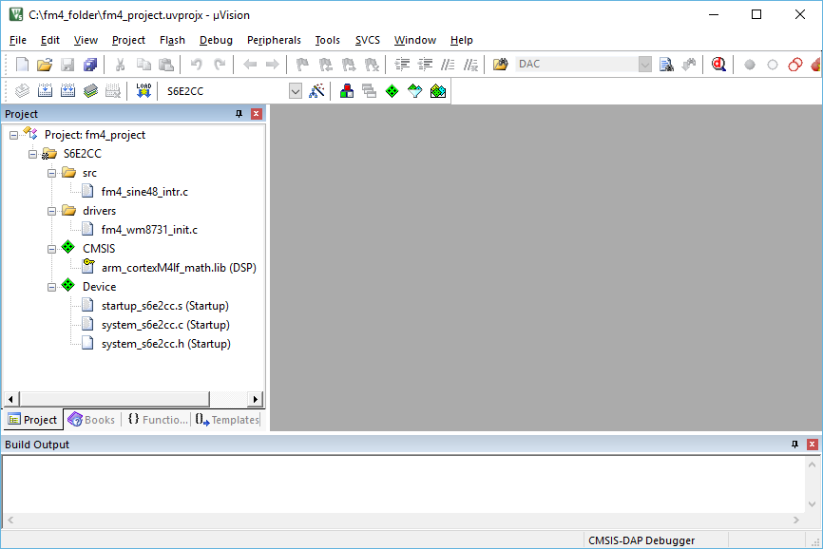

Initially the project should contain program example fm4_sine48_intr.c. *Build* the project and switch to the *Debugger* and *Run* the program. You should get a 1kHz tone output on the HEADPHONE OUT socket on the Pioneer Kit.

To run different example programs, simply replace file **fm4_sine48_intr.c** in the *MDK-ARM* project with another source file. All of the source files from the book are in the **fm4_folder**  folder. Detailed instructions for the different program examples are contained in the book.